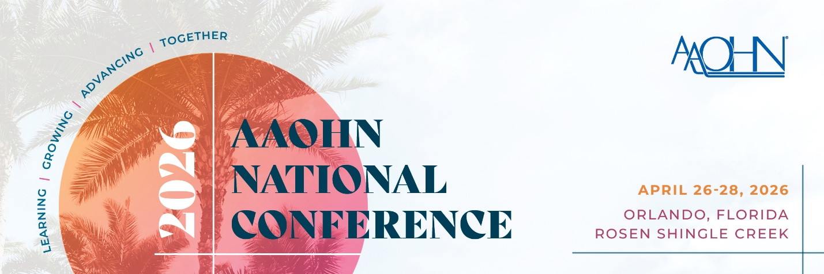
Guidelines for Submission:
- Login to your AAOHN account.
  - *All submitters must have a Member or Guest Account.
- If you are creating a new account, follow the prompts to create a profile.
- You will need to select MY AAOHN and then Community for Competitions to submit your proposal for the 2026 AAOHN National Conference.

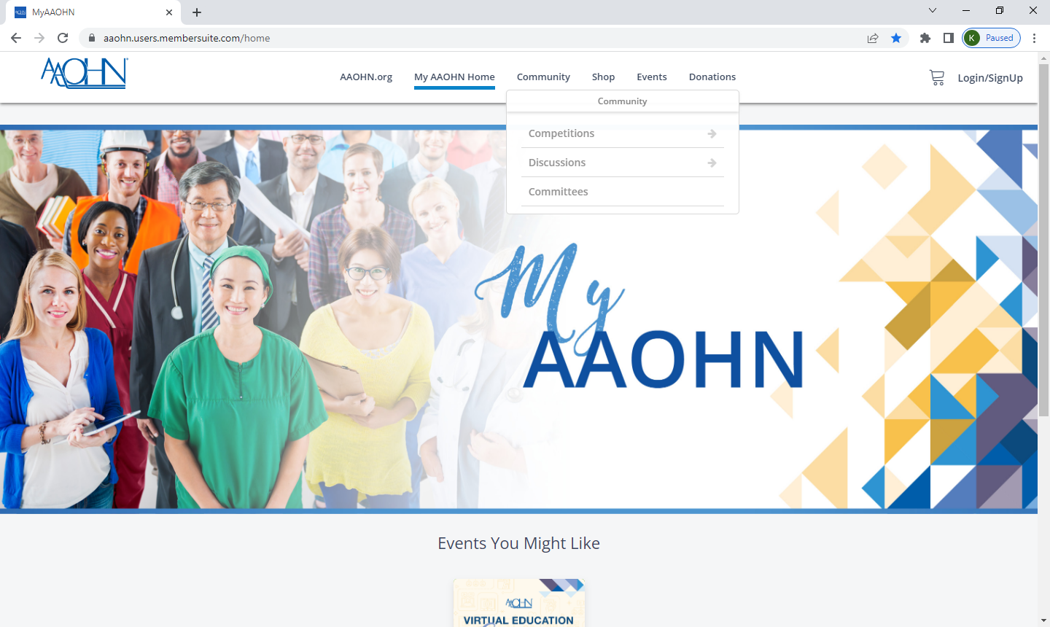

- Select View Open Competitions to select the Annual Conference 2026 Proposals. Then Select the Annual Conference 2026 Proposal Submission.
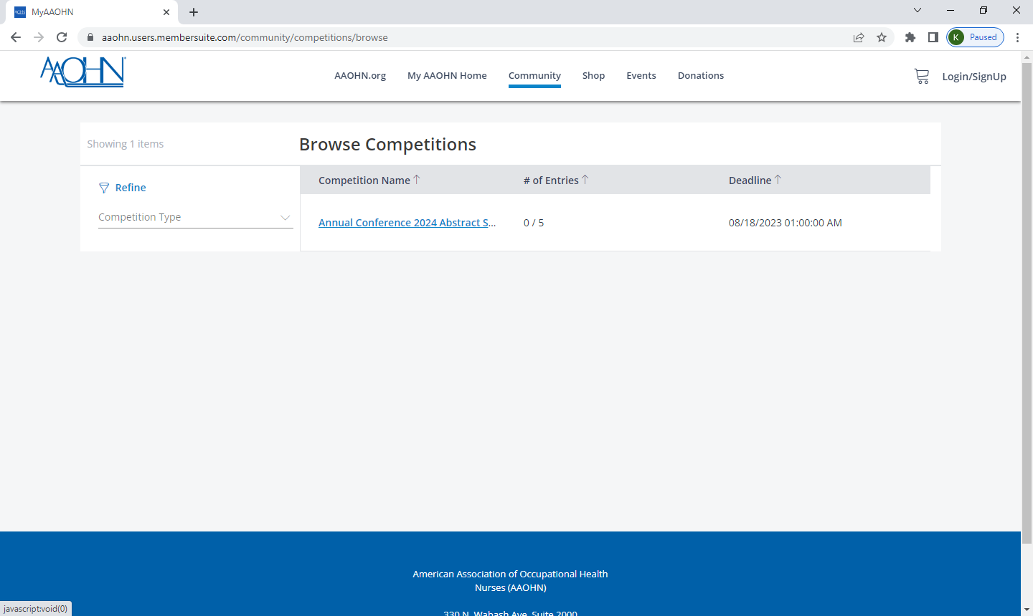

- You may review your submission or submit additional proposals through the deadline.
- Select Type- Use Dropdown to select lecture, micro-presentation, panel, or poster presentation.
- On your entry, you will enter your Session Title twice (see the screenshot below from 2024 - please note to look for 2026). 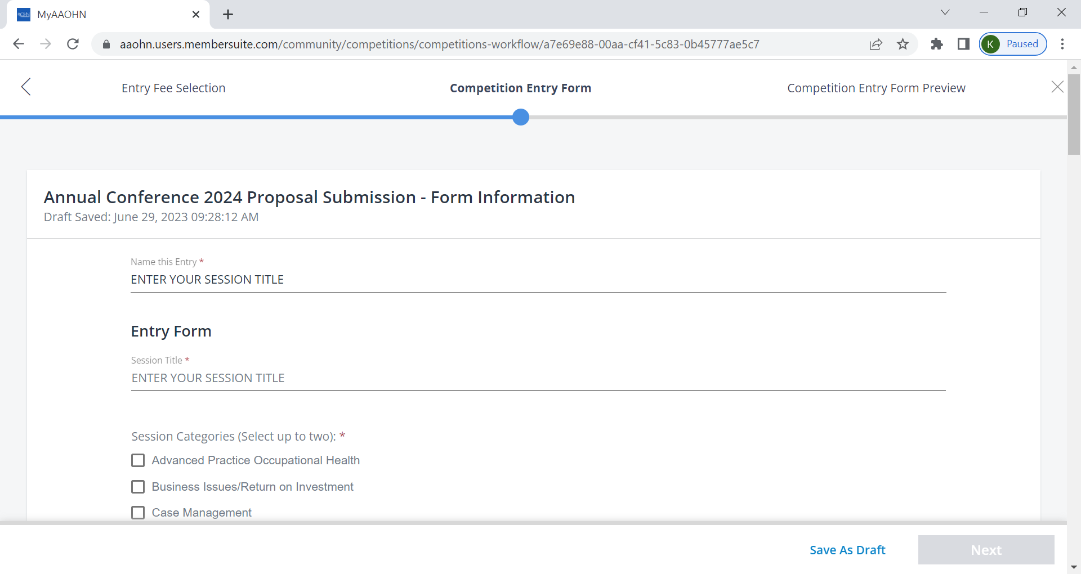

- Please note that you must attach a Biographical/Financial Relationship form AND an Education Planning Table to submission to be considered. If you are struggling to attach the file, please reach out to education@AAOHN.org.

  - AAOHN Bio/Financial Relationship - Complete one for each presenter included in your submission(s).
    - If you have trouble uploading multiple forms for more than one presenter, please combine each bio form into one word document.
  - AAOHN Education Planning Table - Complete one per submission.
Deadline:
Conference submissions close on Sunday, July 13th.

Author proposals are welcome and will undergo an open, competitive peer-review process for selection. Keep in mind that proposals will score highest on topics that reflect leading-edge, evidence-based, forward-thinking and innovative topics, address mid-and advanced-levels of practice and are appealing to a large number of conference attendees. Proposals that do not show clear and accurate interpretation of implications and recommendations for practice gaps, education, research, and/or policy for one or more of the occupational health nursing subspecialties will not be accepted. Proposals received after the deadline will not be reviewed.

The American Association of Occupational Health Nurses, Inc.’s purpose is to provide evidence-based information with implications for occupational and environmental health nursing. Material presented at the national conference, available on the website, or provided in any printed materials must be evidence-based, of professional quality, and demonstrate an absence of proprietary or prejudicial/biased commentary. Anecdotal observations should be limited in their scope and not presented as proven fact. It is inappropriate to endorse or imply endorsement of any specific product or service. Presentations may be recorded.

For further information or questions, please contact education@aaohn.org .

